BOTANY DEPARTMENT
SEMINARS
YEAR 2015-16
D.MUSWIRA 1st B.Z.C. 14/10/2015
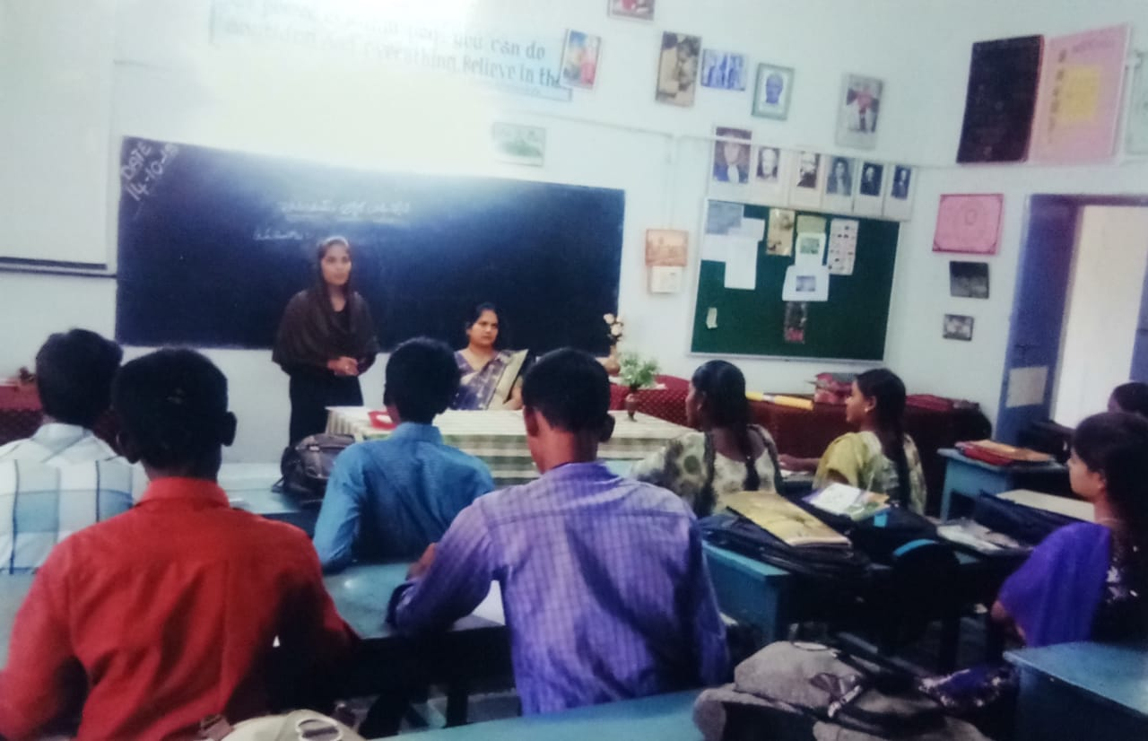
PENICILLIUM
D.SUCHARITHA 2ND B.Z.C. 19/01/16
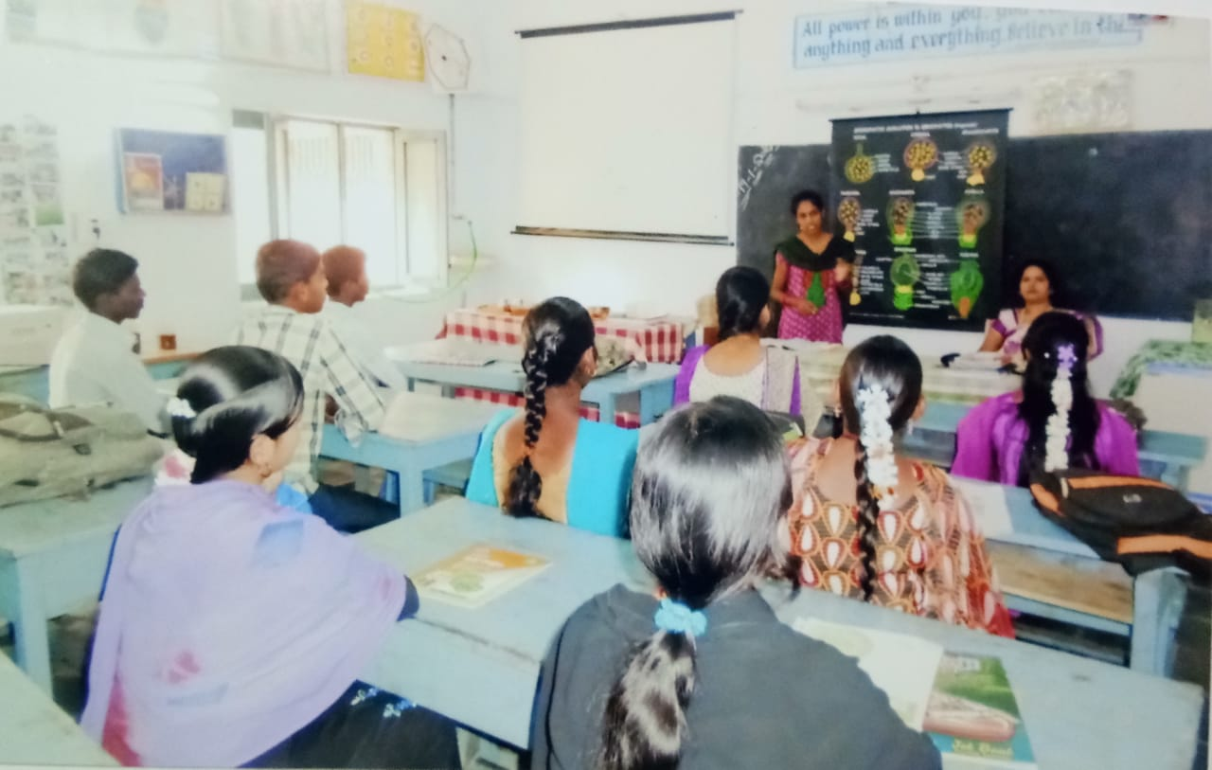
EMBRYOLOGY
P.SARADHA 3RD B.Z.C. 24/03/2016
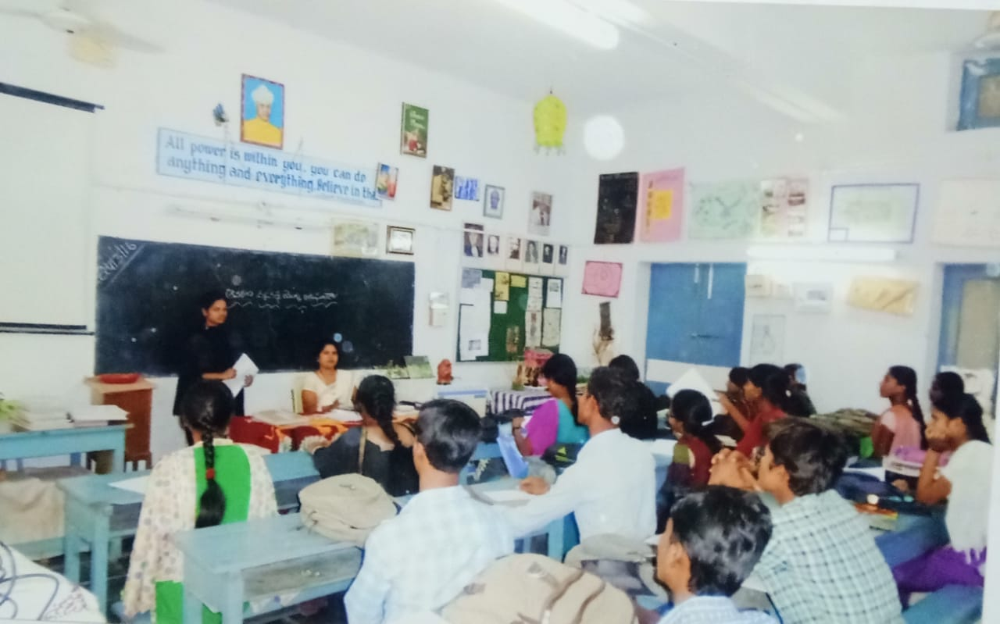
ECOSYSTEM
YEAR 2016-17
K.ANURADHA 1ST B.Z.C. 30/09/2016
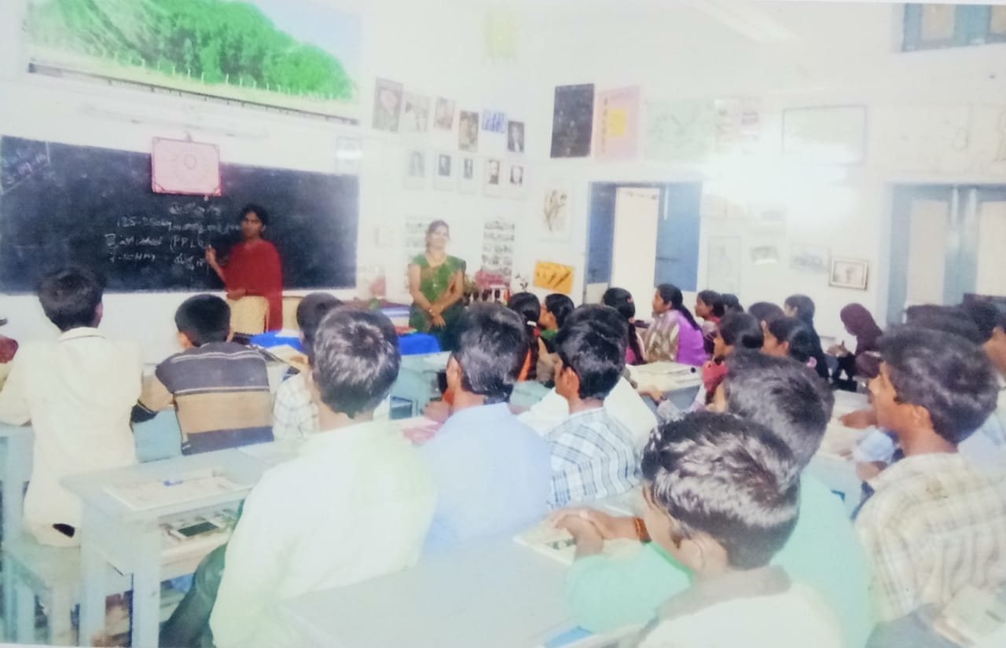
MICOPLASMA
S.THASLEEM 2ND B.Z.C. 21/01/2016
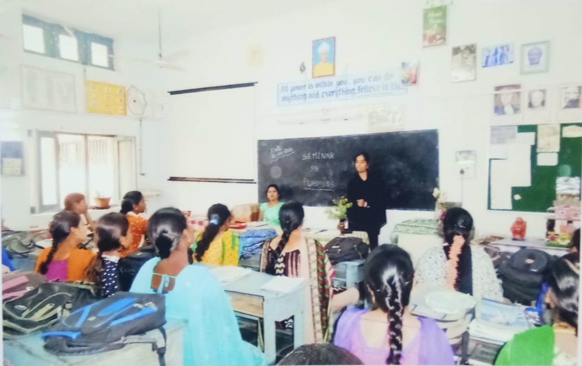
PLASMIDS
B.GANESH 3RD B.Z.C. 27/09/2016
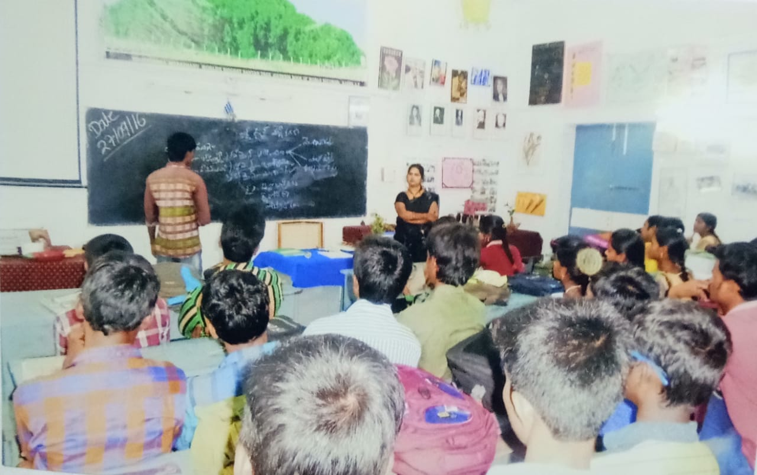
DNA
YEAR 2017-18
G.PRAVEEN KUMAR 1ST B.Z.C. 27/10/2017
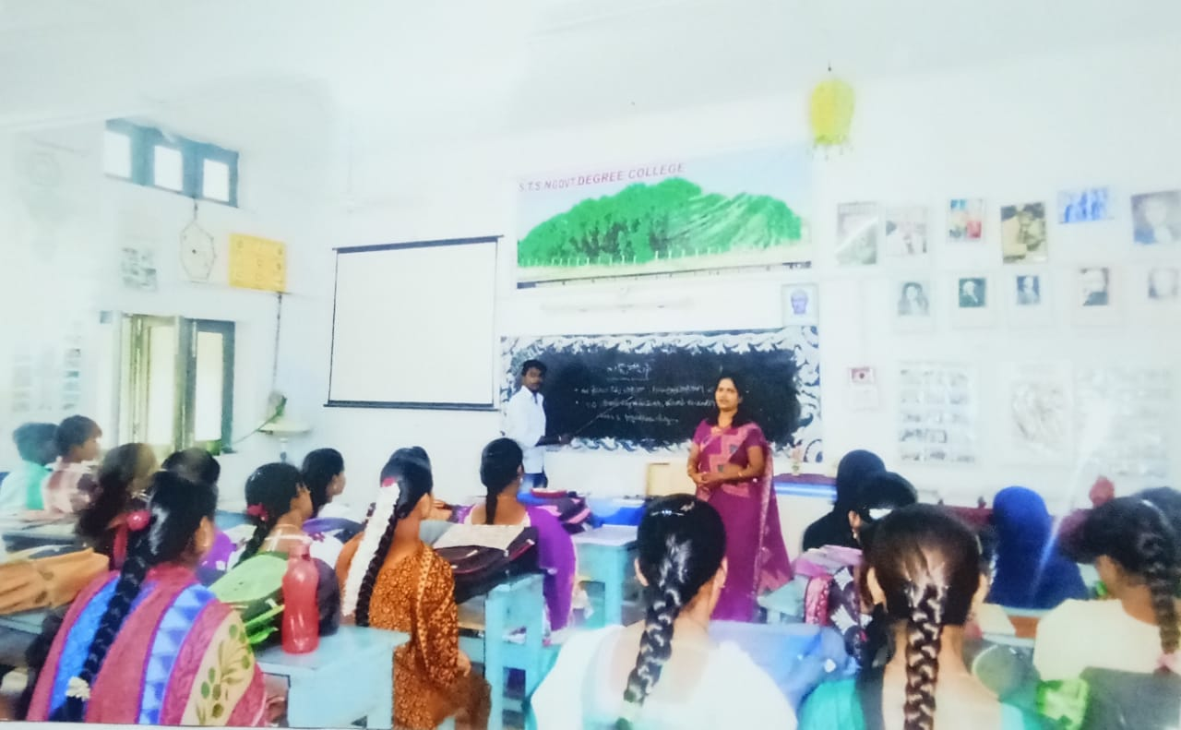
ECTOCARPUS
G.RAJESWARI 2ND B.Z.C. 23/10/2017
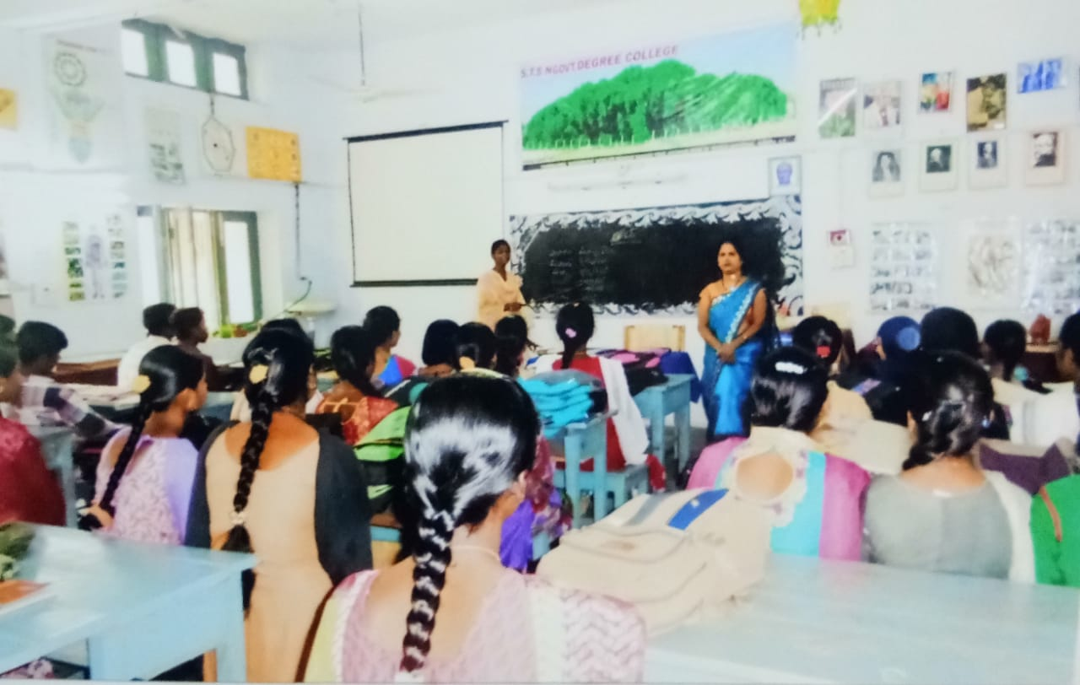
ANNONACEAE
J.PALAVI 3RD B.Z.C. 23/10/2017
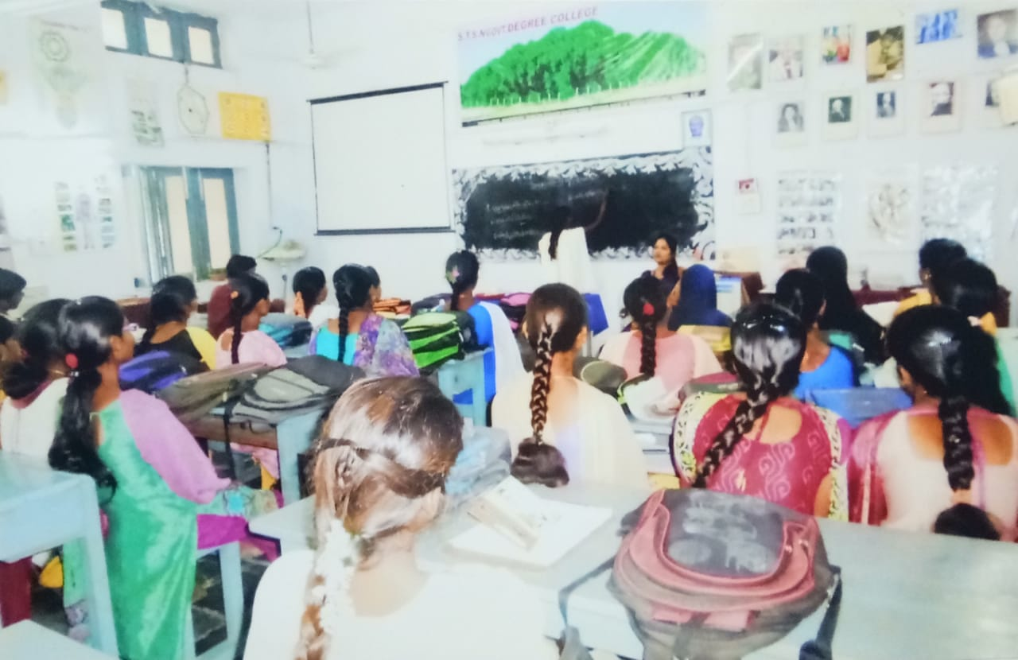
FOOD CHAIN
YEAR 2018-19
J.LAVANYA 1ST B.Z.C. 05/01/2019

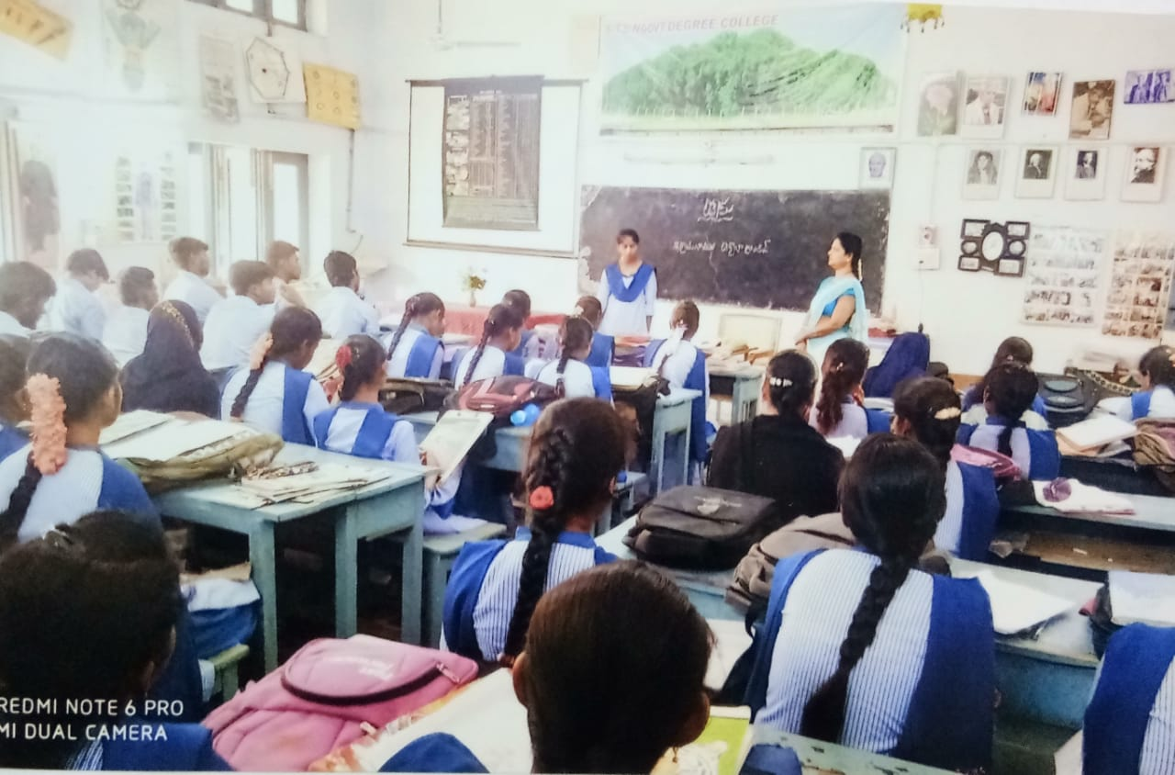
WOOD
G.PUSHPA LATHA 2ND B.Z.C. 13/12/2018
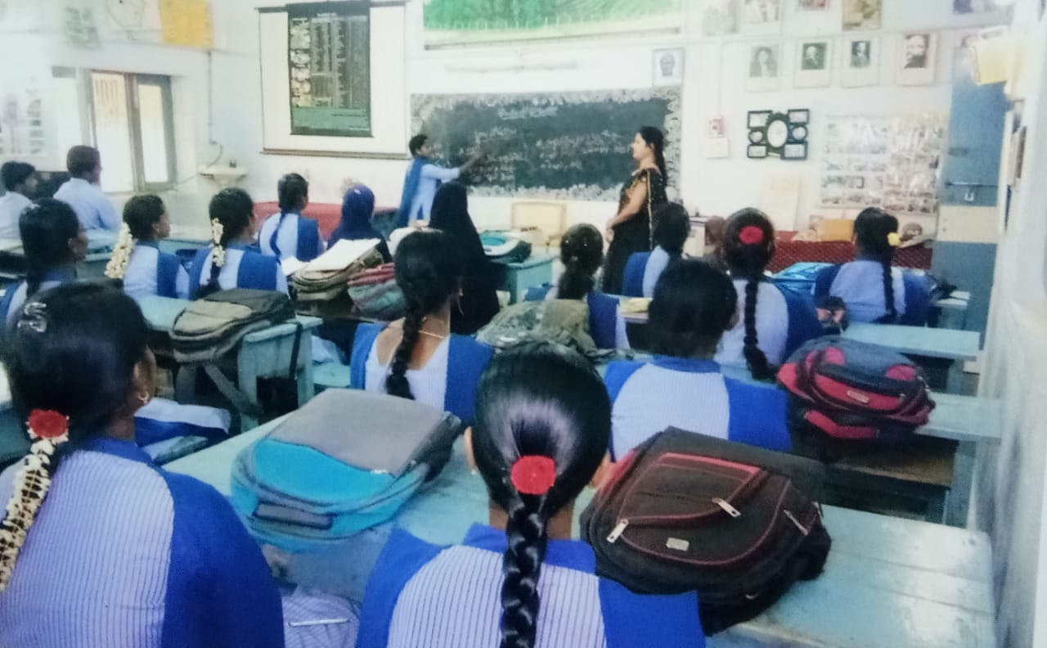
MACRONUTRIENTS
N.RUBINA 3RD B.Z.C. 27/12/2018
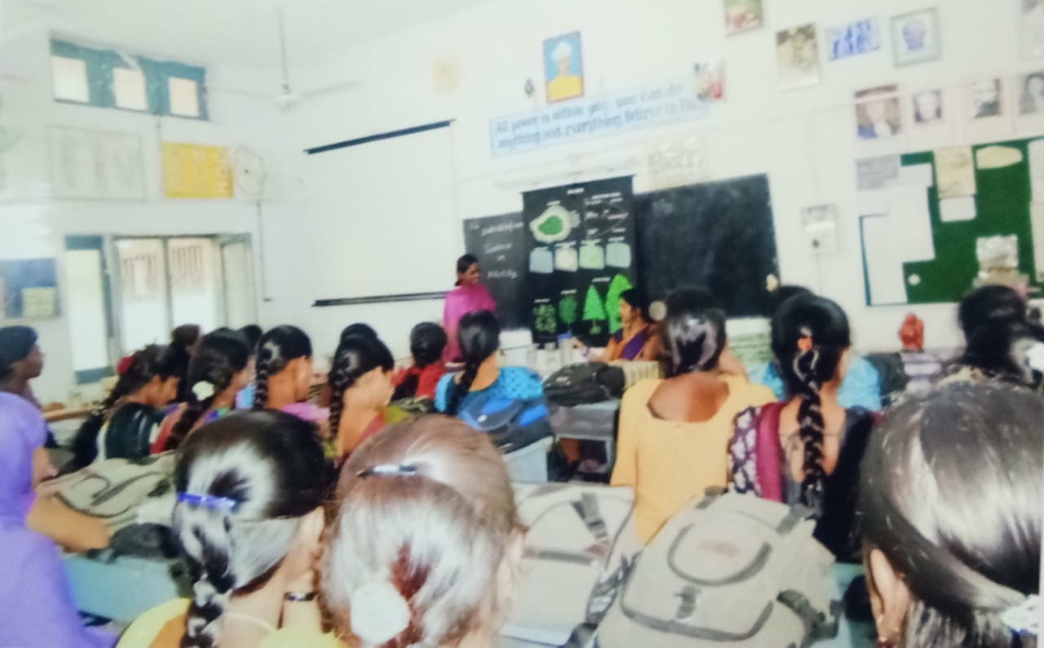
XEROSERE
YEAR 2019-20
A.CHANDRAKALA 1ST B.Z.C. 16/07/2019
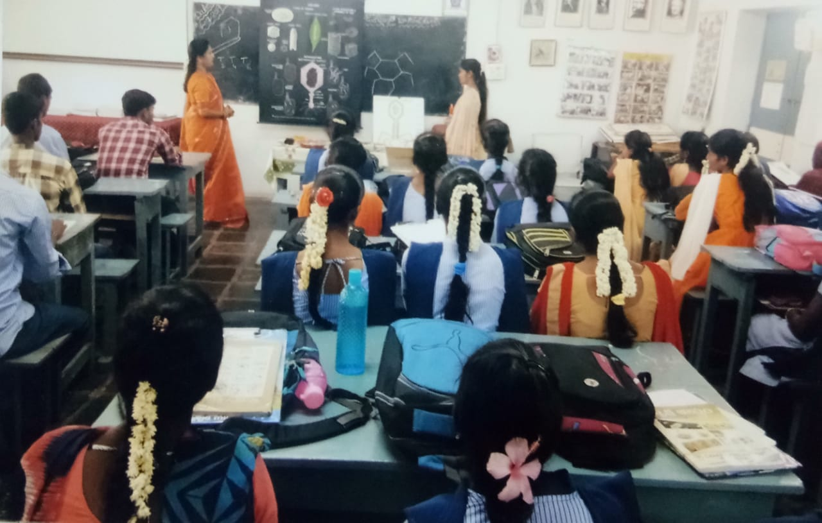
BACTERIOPHASE
A.KAVITHA 2ND B.Z.C. 04/02/2020
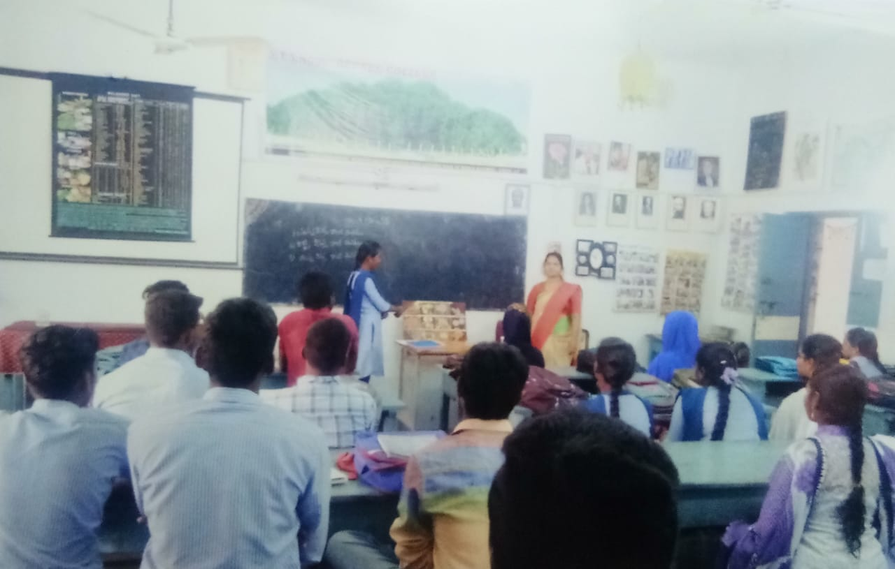
PHOTOPERIODISM
B.JAYASUDHA 3RD B.Z.C. 05/02/2020
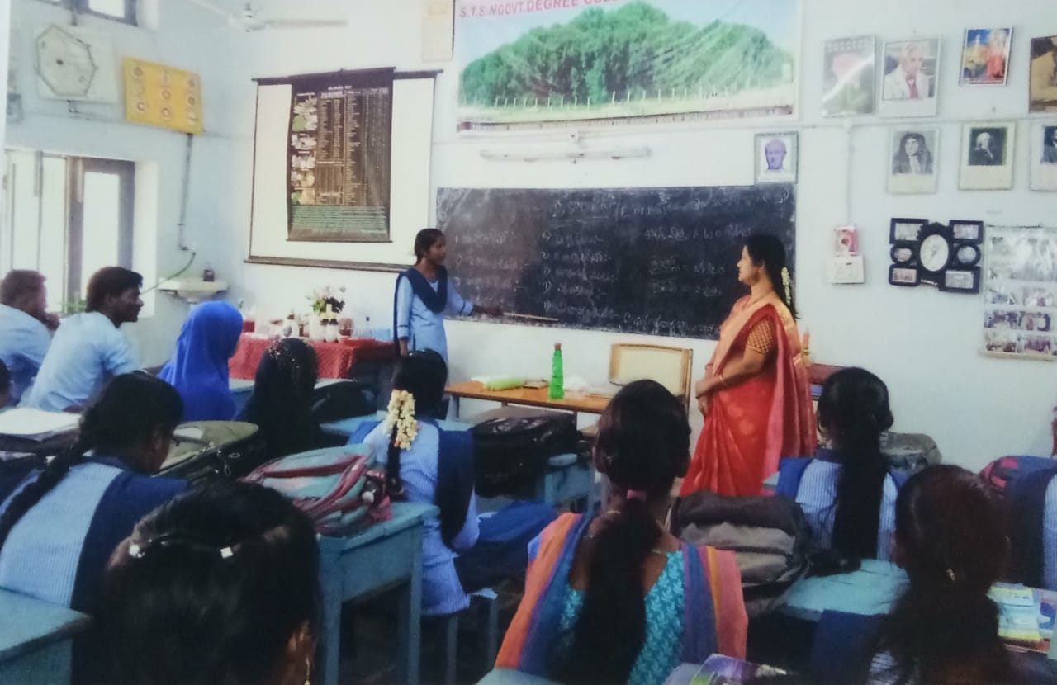
GLYCOLYSIS
Dr.K.SREE DEVI
Lecturer In-Charge

